

**HAWASSA UNIVERSITY INSTITUTE OF**

**TECHNOLOGY**

**FACULTY OF INFORMATICS**

**DEPARTMENT OF INFORMATION TECHNOLOGY**



**job portal**

A PROJECT SUBMITTED IN PARTIAL FULFILLMENT OF THE REQUIRMENT FOR THE AWARD OF BACHELORS OF SCIENCE(B.Sc.) IN INFORMATION TECHNOLOGY



**Name ID**

1ABEL KIBEBE IT/0006/09

2 BERHANU SOMEGA IT/0020/09

3 HAILEMARIAM YIHUN IT/0033/09

4 YETMWORK ABERA IT/0068/09

5 MESERET WUBIE IT/0049/08

6 DAWIT TEFERI IT/0025/09

**DECLARATION**

We hereby declare that the entire thesis work entitled, “JOB PORTAL SYSTEM” submitted to the department of Information Technology, Hawassa University College, in fulfilment of the requirement for the award of the degree of BSc Information Technology.

I further declare that the thesis either in part or full, has not been submitted earlier by me or others for the award of any degree in any University

**Name and signature of the project group members**

1. ABEL KIBEBE ………………………………………..
2. BERHANU SOMEGA ………………………………………..
3. HAILEMARIAM YIHUN ………………………………………..
4. YETMWORK ABERA ………………………………………..
5. MESERET WUBIE ………………………………………..
6. DAWIT TEFERI ………………………………………..

This is to certify that I have read this project and that in my opinion; it is fully adequate, in scope and quality, as a project for the degree of Bachelor of Science.

**Adviser Name Signature**

Mr. Wondwosson Ergete ……………………………………….. ………………………………………..

Examiner name

1. Exaimner 1 ………………………………. ………………………………….
2. Examiner 2 ………………………………. ………………………………….
3. Examiner 3 ………………………………. ………………………………….
4. Examiner 4 ………………………………. ………………………………….

# ACKNOWLEDGMENT

First of all, we would like to thank the GOD for helping us from the beginning to the end of the project. The team would like to give deepest thanks to those who helped us for accomplishment of this project. Firstly, we would like to say thanks with great respect to our advisors Mr.Wondessen for his full guidance, support and encouragement throughout the Documentation of this project. Secondly, we would like to thank Informatics Faculty head, our friends and classmate for their suggestion and support. Finally, we would like to thank for all those participated and gave support in our proposal writing

# Acronyms and Abbreviation

**Course**: Subject

**CPU**: Central Processing Unit

**Cr. Hr**.: Credit Hours

**F.K**: Foreign key

**HTTP**:Hyper Text Transfer Protocol

**Instructor**: Teacher

**MYSQL**: Structured Query Language (database management system)

**SDD**: System Design Document

**OOSAD**: Object Oriented System Analysis and Design

**PHP**: Hypertext Preprocessor (text editor)

**P.K**: Primary key

**RAM**: Random Access Memory

**Scheduled**: prepared

**SWOT**: Strength, Weaknesses, Opportunities and Threat.

**UML**: Unified Modeling Language

**WAMP**: Windows, Apache, MSSQL, and PHP/Perl/Python)

# Abstract

People are unable to get access to job opportunities due to inefficient distribution of information on job offers but now the Internet has made a huge impact on knowledge management and information dissemination all over the world. The Internet has changed the way of looking for job vacancies and searching for right and qualified candidates, through the development of job portals. Job portal system has made job searching processes easier. This project deals with the design and development of a Job Portal System. The purpose of this project is to develop a web-based system for users that will eliminate or reduce the manual work in job searching process and also reduce cost and time spent when advertising job vacancies. It allows job seekers to register online, search and apply for employment and also allows recruiters to register online, post job vacancies and look for suitable candidates.

Table of Contents

ACKNOWLEDGMENT ii

Acronyms and Abbreviation iii

Abstract iv

Chapter One 1

1.1 Introduction 1

1.2 Background of the project 2

1.3 Team composition 3

1.4 statement of problems 4

1.5 Objective of the project 6

1.5.1 General Objective 6

1.5.2 Specific objectives 6

1.6 Feasibility Analysis 7

1.6.1 Operational feasibility 7

1.6.2 Technical feasibility 7

1.6.3 Economic feasibility 8

1.6.4 Behavioral Feasibility 10

1.6.5 Schedule Feasibility 10

1.7 Scope and significance of the project 11

1.7.1 Scope of the project 11

1.7.2 Significance of the project 12

1.8 Target beneficiaries of the system 12

1.9 Methodology 13

1.9.1 Data source 13

1.9.2 Fact finding techniques 13

1.9.3 System analysis and design methodology 14

1.9.4 Development tools 14

1.9.5 Required resources with Costs 15

Chapter Two 16

Description of the Existing System 16

2 Introduction of Existing System 16

2.1 Strength of Extisting System 16

2.2 Weakness of Existing System 17

2.2 Proposed System 17

2.4 Major functions/activities in the existing system like inputs, Processes & outputs 18

2.5 Business rules 18

2.6 Bottlenecks of the existing system (using for example PIECES frame Work) 19

2.6.1 Performance (Response time) 19

2.6.2 Input (Inaccurate/redundant/flexible) and Output (Inaccurate) 19

2.6.3 Security and Controls 19

2.6.4 Efficiency 19

2.7 Practices to be preserved 20

2.8 Requirements of the Proposed System 20

2.8.1 Functional Requirements 20

Chapter Three 22

System Analysis 22

3.1 Introduction 22

3.2 System Requirement Specifications (SRS) 22

3.3 Use Case Diagram 23

3.4 Potential Actors and Use Cases 24

3.5 Use case documentation 25

3.6 Sequence Diagram 36

3.8 Analysis level class diagram (conceptual modeling) 53

3.9 User Interface Prototyping 54

3.10 Supplementary specifications 55

Chapter Four 56

4. System Design 56

4.1 Introduction 56

4.1.1 Purpose of the System Design Document (SDD) 56

4.2 Architectural Design 56

4.3 Deployment Diagram 58

4.4 Database Design 59

4.4.1 ER-Diagram 60

4.4.2 Relational Schema 62

4.4.3 Database Normalization 63

Chapter Five 72

5 Conclusion and Recommendation 72

5.1 Recommendation 73

Bibliography 75

List of Tables

Table 1:Team composition 3

Table 2 Hardware cost 8

Table 3 Software cost 8

Table 4 Schedule Feasibility 9

Table 5: Development Tool 14

Table 6: Resource Cost 14

Table 7 Actors and Use Cases 24

Table 8 System Use Case description for register 25

Table 9 System Use Case description for Login 26

Table 10 System Use Case description for Search Job 27

Table 11 System Use Case Description for View Detail 27

Table 12 System Use Case description for view jobs by category 28

Table 13 System Use Case description applying for a job 29

Table 14 System Use Case Description for Manage resumes 30

Table 15 System Use Case description for managing an Account 31

Table 16 System Use Case description for approve 31

Table 17 System Use Case description for posting a job 32

Table 18 System Use Case description for select applicants 33

Table 19 System Use Case description for view notification 34

Table 20: System Use Case description for the view exam result 35

List of Figures

Figure 1 Use case diagrams 23

Figure 2 Sequence Diagram for Register 35

Figure 3 Sequence diagram for login 36

Figure 4 Sequence Diagram for Search Job 36

Figure 5 Sequence Diagram for View Job by category 37

Figure 6 Sequence Diagram for View Latest Job 38

Figure 7 Sequence Diagram for manage Resume 38

Figure 8 Sequence Diagram for manage account 39

Figure 9 Sequence Diagram for apply job 40

Figure 10 Sequence Diagram for post Job 41

Figure 11: Sequence Diagram for Approve Employer 42

Figure 12Activity Diagram for login 43

Figure 13 Activity Diagram for register 44

Figure 14 Activity Diagram for Search Job 45

Figure 15 Activity Diagram for View Job Detail 46

Figure 16 Activity Diagram for Post Job 47

Figure 17 Activity Diagram for View eligible Applicant 48

Figure 18 Activity Diagram for Approve Employer 49

Figure 19 System class diagram 50

Figure 20: User interface prototype 51

Figure 21: Architecture design of the system 54

Figure 22: Deployment diagram design 55

# **Chapter One**

## 1.1 Introduction

Online job portal system (JPS) is a web-based system in which Jobseekers can register themselves online, view organization requirements and apply for the suitable job. The system provides online help to the users all over the world. This kind of system plays an important role in simplifying the recruitment process. The system has facilities where prospective candidates can upload their CV’s and Apply for Job suited to them. It also makes it possible for organization to post their staffing requirements and view profiles of interested candidates. Earlier Recruitment was done manually and it was all at a time-consuming work for both Job seekers and Employers. Now it’s all possible fractions of second. The system has been designed to do a whole lot more than just reduce paperwork. Job portal system makes possible managers to access information that is crucial to managing their staff. The primary purpose to develop this system to optimize Recruitment process for an organization, besides the qualified applicant could be sort by this system based on their qualification and company requirements. This system contains server that contains the database of Job seeker and Employer; client that contains GUI (graphical user interface). And also, the system we are going to develop will have detailed information about the job (job search, latest job, job categories). In this time everyone, either experienced or fresher, is in search for a Job. This system can prove to be very helpful since it allows users of different profile to be registered and search job on the basis of their qualification. Every user can access through Job title, location of Job and apply for multiple jobs at a time. Generally, this system will improve and make easy the way of finding for jobs by minimizing the cost and effort of Jobseekers with a special feature like user friendly interface, possibility of storing and accessing data locally. This means the Jobseeker will not waste budget by moving from place to place.

## 1.2 **Background of the project**

Technology is a body of knowledge used to create tool, develop skills, and extract or collect materials. It is also the application of science (the combination of the scientific method and material) to meet an objective or solve a problem. In addition, technology is a meaningful application in invention, production, and utilization of goods and services, and in the establishment of human activities. Job portal system is a web-based application, which helps end user to find a job with searching criteria like preferred location, job type, and work profile. One can post his/her details on this system with all relative information. The project and implementation helps in proper management and coordination of the records and information. Computerized Job portal system is developed to facilitate the General Administrative system to manage information of the Job Seeker and Job Provider and the processes involved in a Placement company so that, the organization can access accurate information quickly and easily as and when required, thereby improving its operational efficiency and effectiveness. In today’s competitive environment, where everybody is on the top, information plays very crucial role. As fast as information is accessed and processed, it can give good result. Today is a fast way of transferring Data and Information over wide area, hence we have used internet as a way for exchanging information. Computerized Systems helps to fulfill these goals. Computerization of the official works will help in doing lot of manual work quickly. It will help in easy storage and access of all information, in short period of time.

## 1.3 Team composition

|  |  |  |  |  |
| --- | --- | --- | --- | --- |
| **Title name** | **Job portal system** | | | |
| Prepared by | Name | ID | E-mail | Responsibility |
| Abel Kibebe | IT/0006/09 | Abelkibebe5@gmail.com | Programmer |
| Berhanu Somega | IT/0020/09 | somegaberhanu@gmail.com | Project Manager |
| Hailemariam Yihun | IT/0033/09 | haile123mariam.@gmail.com | System Analyst |
| Yetmwork Abera | IT/0068/09 | yetmworkabera@gmail.com | System Designer |
| Dawit Teferi | IT/0020/09 | dawirteferi@gmail.com | System Designer |
| Meseret Wube | IT/0025/08 | meseretwubie@gmail.com | Programmer |
| Date | Dec 2019 | | | |
| Advisor | Mr. Wondwossen Ergete | | | |

Table 1:Team composition

## 1.4 statement of problems

Currently, In Ethiopia employment has been made manually and is being made manually, most of job seekers viewing available jobs, or applying for the job at the agency can be done for which job seekers has to go the agency and check the available jobs at the agency by reading different Newspapers, job announcements posts on notice board, In the current Ethiopia where technology is also advancing the job recruitment process has abit changed though some problems still occur. there are still some online web applications for the job portal like Ezega.com, MJobs.net , Ethiojobs and ethio translation, but each websites has their own problem.

Problem definition based on the websites.

**Ezega.com**

This website has a very simple and good interface but it couldn’t let you to sign in it asks you to register by providing forms but after you fill the forms it sends you an activation code to your Email, after u activate your account it says there is no user with this name

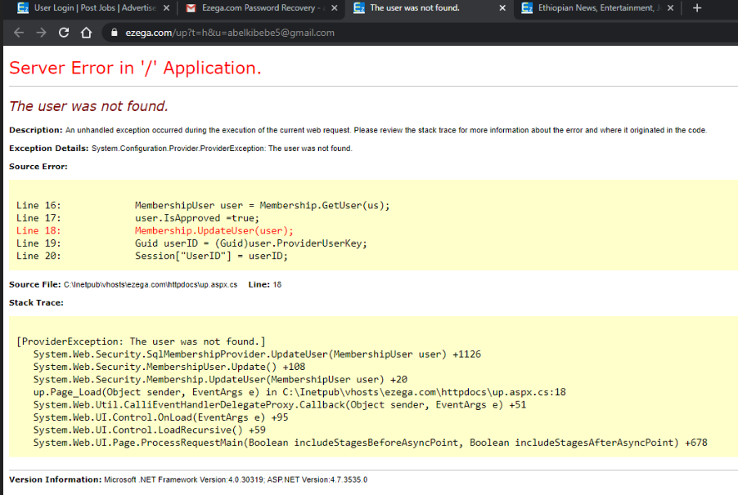

As long as we can’t login its difficult to judge other features of the websites.

**Mjobs.net**

After you use it for sometimes the website crashes and it has poor response time, we have waited a lot to just register as a jobseeker and still an error response.

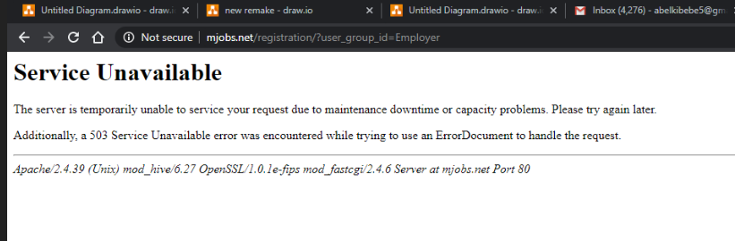

**Ethiotransaltion.com**

it is a website in which it enables a Jobseeker to login to his/her facebook account and have an opportunity to see posted jobs, and this website is only for jobseekers, an employer cannot post jobs by itself only the admin posts the selected jobs

* There is no application to fill for the jobs
* You can’t upload CV.
* Jobseekers only like, share and view Jobs.

**Ethiojobs.com**

This website is way better than the website that are listed above but it has a problem too,

1. after you register as an employer it took long for the admin to apporove the request to be an approved Employer(it’s been like a weak since we requested to be an Employer but still has no response ), we don’t know for how long we have to wait.
2. When you try to sign in with a wrong Username it takes you to the jobseeker page without showing you where the problem is. This causes an ambiguity to the user

Generally, the current system has the following problems

* Has no exam date announcement
* Has no Exam result announcement
* Can’t schedule an interview.
* Selected candidate announcer(since anyone can apply to a job but not everyone take the exam or anyone cannot take an interview so that selected applicant are going to compete for a certain job and based on data availability online then the best candidate can be brought to competition and provided with sort based on their CGPA and duration of work Experience.)

## 1.5 **Objective of the project**

### 1.5.1 **General Objective**

The general objective of job portal System is To providing web-based and centralized Recruitment Processing System that is time and effort effective system for Job Seekers and job providers.

### 1.5.2 **Specific objectives**

In order to achieve the general objective of the project, the following Specific objective of the project should be addressed.

* Gathering data or requirement through observation and interview from end user and client.
* Analyzing the data or requirement (functional and nonfunctional requirement) to satisfy the client or end user need.
* If it is, we design the system otherwise the requirement must be reanalyzed.
* The design of the system must depend on the requirement of the system.
* Testing the system designed if it is the just the system we want.
* After the design tested and satisfy the requirement, system implementation will be accomplished.
* Designing database for the system.
* Each activities of the project is tested before the next process start. Finally the system will be deployed.
* Implement and testing the proposed system.
* Evaluating the alternative solution.

## 1.6 Feasibility Analysis

### 1.6.1 Operational feasibility

The operational feasibility is concerned with the operability of the system after it has been installed. The new system can provide sufficient service for the job seekers and employers, there was bulky process in giving service in manual processing or in the existing online system. This implies that the jobseekers or employers cannot be satisfied for the service they get. But this proposed system is automated consequently the both can get sufficient service.

Therefore, the proposed system or the new system is operationally feasible because it can fulfill the following requirements: -

* Satisfy the customer needs or requirements
* Provides the end users with timely, accurate, reliable, flexible and useful information.
* We believed that our project would be workable and user friendly. Then our newly proposed project is operationally feasible.

### 1.6.2 Technical feasibility

Technical feasibility is a study of resource availability that may affects the ability to achieve an acceptable system. This evaluation determines whether the technology needed for the proposed system is available or not.

When we say our new system is technically feasible the proposed system needs easily maintain and fix without requiring high experts because the system will be developed by familiar programming language the project team members have learned programming languages that required for the successful completion of the project such as java script, CSS, HTML, PHP, and MySQL. Our new system can run on the existing computer system and hardware

The aspects of our study included the following factors.

* It must have a graphical user interface that assists customers that are not from IT back ground.
* Platform independent.
* Easy to debug and maintain.
* inherent features for security Efficient data retrieval and maintenance
* The system is operationally feasible as it very easy for the End users to operate it. It only needs basic information about Windows platform.

### 1.6.3 **Economic feasibility**

Since the system is developed as part of project work, there is no manual cost to spend for the proposed system. Also, all the resources are already available, it gives an indication of the system is economically possible for development.

The Job seekers also need not to waste their money as travel expenditure to find the jobs. So the proposed system is economically feasible.

**Tangible benefits**

A benefit that we get from using this web-based application can easily measure in the following manner.

* Reduces the occurrence of errors.
* Cost reduction and avoidance.
* Reduce the response time of activities
* Information processing efficiency

**Intangible benefits**

In this case we can see the benefits of using this web-based application that are not easy to measure in terms of money.

* Increase information accuracy.
* Increasing user’s motivation.
* Increase security
* Increase efficiency

**Tangible cost**

To get accurate information about materials the project team observes the market directly. From our project point of view the following items are considered as tangible. Because our team can easily measure them in terms of money.

These costs include:

* Hardware cost
* Software cost
* Development cost
* Operational cost

Hardware cost include the cost to buy a computer and scanner, in our case there is no cost for the software because we are using open source software(jdk,eclips), the development cost includes the cost needed for programmer, manager etc… and operational cost is the cost required to operate the system in the development phase.

**Cost of the project**

* **Hardware cost**

|  |  |  |  |  |  |
| --- | --- | --- | --- | --- | --- |
| **No** | **Material** | | **Amount** | **Price per unit** | **Total price** |
| 1 | Pen | | 6 | 9 Birr | 54Birr |
| 2 | Flash disk | | 2 | 220 Birr | 440Birr |
| 3 | For Print | | 85 sheets | 2 Birr | 170Birr |
| 4 | A4 size paper | | 1 Desta | 150 | 150 |
| Total | | 814 birr | | | |

Table 2 Hardware cost

* **Software cost**

|  |  |  |  |
| --- | --- | --- | --- |
| **No** | **Material** | | **Price per unit** |
| **1** | XAMPP Server | | Free |
| **2** | Microsoft office 2016 | | Free |
| **3** | Micro soft Visio 2010 | | Free |
| **4** | E-draw | | Free |
| **5** | MYSQL | | Free |
| **7** | Google Chrome | | Free |
| Total | | 0.00 | |

Table 3 Software costs

### 1.6.4 Behavioral Feasibility

Our system is behaviorally feasible, because we could say almost all job seekers are familiar with how technology could simplify their work or their life, so in the sense of this both employers and jobseekers are open minded towards the acceptance of this new system, and there is no specialized training needed for the users. Disregarding the initial expenses, the candidate system was assessed to be feasible in all ways. Our system is free from any political and environments difficulty.

### 1.6.5 Schedule Feasibility

All the team members expect that the project will be completed within the time frame stated, so that the system will be feasible regarding schedule

|  |  |  |  |  |  |  |  |  |  |  |  |  |  |  |
| --- | --- | --- | --- | --- | --- | --- | --- | --- | --- | --- | --- | --- | --- | --- |
| Activities | **Schedule** | | | | | | | | | | | | | |
| 5 weeks | 6-8  Weeks | | | 9-13  Weeks | | | 14-20  Weeks | | | | 21-22  Weeks | | |
| Project Proposal |  |  |  |  |  |  |  |  |  |  |  |  |  |  |
| Requirement Analysis |  |  | | |  |  |  |  |  |  |  |  |  |  |
| System and Object Design |  |  |  |  |  | | |  |  |  |  |  |  |  |
| Implementation |  |  |  |  |  |  |  |  | | | |  |  |  |
| Documentation and Submission |  |  |  |  |  |  |  |  |  |  |  |  | | |

Table 4 Schedule Feasibility

## 1.7 Scope and significance of the project

### 1.7.1 Scope of the project

Job portal System enables the users to have the typical recruitment facilities and features at their disposal. The system makes it simpler to share and manage organization’s human resource requirements with higher efficiency of easiness. This kind of systems is specifically designed for organization to help in solving staffing problems and managing human resource department activities.

The scope of system will include: -

* Maintain Job seeker and Employer records
* Job Application: In this new system, users are able to apply the job via internet by filled in the required forms.
* Provide Job Postings with details.
* Provide a way to upload resume.
* Provide Easy information retrieval
* Provide Job searching
* Disallowing unauthorized access.
* Scheduling an interview
* CV Verificaction
* Interview announcement
* Exam date announcement
* Exam result announcement
* Selected candidate announcer
* Providing a way to print the CV.

### 1.7.2 Significance of the project

The main purpose of this project is to develop application which enables the job seekers to apply for jobs that match their qualifications in an easy, cost effective and timely manner .That means it enables the job seekers to search for jobs anywhere at any time. The new system helps handling the important task of employee recruitment process. Users which are applicant can access the system using any computer at any place. They can apply for the job vacancies via internet and check their application status easily. Applicant's data are kept in the database system that is more secure as the paper files are not only wasting. The system enables the process like update, edit and add new data to be easier and faster.

## 1.8 Target beneficiaries of the system

There are different bodies that will be benefited from the new proposed system. The main beneficiaries of this system are both Employers and Jobseekers. Here we have described the benefits that are expected to gain after the development of this system.

**To the team members: -**

* Having knowledge how a real-life (a real-world information system development) problem should be solved.

**To the Employer: -**

* Employers can post a job immediately
* Receive applicant CVs immediately as job seekers come across it
* Costs of posting jobs and/or searching for candidates can be lower than the costs of using traditional search firms and/or advertising methods.
* The system is cost-effective

**To the Jobseeker: -**

* Jobseeker benefit immensely from the wider scope they gain through online
* By posting their CV’s Online they can be contacted by employers/recruiters directly for opportunities that may not even be advertised.
* Jobseekers can post their CVs online while keeping their names and present employer's name confidential.

## 1.9 Methodology

Methodology is the system of methods how to perform gathering information, analyze and design the system, implement, test and evaluate using different ways. Most used methodologies are prototyping, iterative, incremental, waterfall, agile, etc. Among them we select iterative development methodology for our system. The requirements for iterative development are requirement gathering, analysis and design, coding, testing and acceptance. The advantage of iterative development method is incremental (multiple releases), cooperative (a strong cooperation between developer and client), straightforward (easy to understand and modify) and adaptive (allowing for frequent changes).

### 1.9.1 Data source

In this section, the current, existing system can be a source of data to produce the newly built system. With this, various approaches to the system of past researches, readings case studies or findings related to the current development of the system. Also we will use primary and secondary data collection methods

### 1.9.2 Fact finding techniques

We gather data from those who were suffered with finding job and to those who have an idea how this portal could solve this problem. To gather data from the staffs and employees the team will use the following techniques.

Those are:

1. **Interview: -**to get the basic information about the existing Employee Recruitment system, the team will interview the staffs and employees in Hawassa University about the services that are given to them, and the problems associated with that environment.
2. **Questioner**: after we finish the interview, we will also use the other methodology of data collection that is a questioner. During this time, we will prepare a questioner and distribute it to employees and staffs who are served to find information on activities and the limitations and strength too.
3. **Observation:** This is another type of method for collecting data and information in which we could witness the actual events which will happen in the organizations. In this method all we have to do is observation and note down the events what we observed.

### 1.9.3 System analysis and design methodology

Analysis and design the system using object-oriented approach. We need a method for analyzing a problem to be solved, a plan for the design of the solution and a construction method that minimizes the risk of error. We have chosen the object-oriented approach (OO) to follow for our proposed system. Object-oriented programming (OOP) is an approach to designing modular reusable software systems. A module is a component of a larger system that interacts with the rest of the system in a simple and well-defined manner. The object-oriented approach is a logical extension of structured programming, a module containing data and subroutines. An object is a kind of self –sufficient entity that has an internal state (the data it contains) and that can respond to messages (call to its subroutines).

Object-oriented design methodology has two phases: -

**Object-Oriented Analysis (OOA):** During this phase, the team will look at the problem domain and with the aim of producing a conceptual model of the information that exists in the area which will be analyzed. And this model the functions of the system (use case modeling), identifying the business objects, organize the objects and also the relationship between them and finally model the behavior of the objects.

**Object-Oriented Design (OOD)**: During this phase the model interactions and behaviors that support the use case scenario, and finally update the object model to reflect the implementation environment. And also transforms the conceptual model produced in object-oriented analysis to take account of the constraints imposed on our system format, so that we will use this phase to refine the use case model to reflect the implementation environment.

### 1.9.4 Development tools

The development tools that will be used to develop the system are listed in the table below: -

|  |  |
| --- | --- |
| Activities | Tools/ Programs |
| Client-side coding | HTML |
| Client-side scripting | JavaScript |
| Platform | MS Windows |
| Database server | Mysql |
| Web server | Apache |
| Server-side scripting | Php |
| Browsers | Mozilla Firefox 3.0. |
| Editors | Macromedia Dreamweaver |
| Documentation | MS Word and Latex |
| Presentation document | MS-Power point |
| Scheduling | MS-Word |
| To design system diagrams | E-draw max 7.9 |

### 

Table 5: Development Tool

### 1.9.5 Required resources with Costs

|  |  |  |  |
| --- | --- | --- | --- |
| Item | Quantity | unit price | total price |
| stationary materials | 3 pen,1desta paper | For pen =27 birr  For paper=150 birr | 177 |
| CD Rom disk | 3 | 15 birr | 45 |
| flash disk | 8Gb | 200 birr | 200 |
| print cost | - | 300 birr | 300 |
| Miscellaneous cost | - | 1000 | 1000 |
| total cost | - | - | 1722 birr |

Table : Resource Cost

# 

# Chapter Two

# Description of the Existing System

## **2** Introduction of Existing System

The existing recruitment system in Ethiopia is happening in two ways the most used way is that Jobseekers viewing available jobs, or applying for the job at the agency can be done for which job seekers has to go the agency and check the available jobs at the agency by reading different Newspapers, job announcements posts on notice board and applying by physically being there. Second, by using some online web applications for the job portal like Ezega.com, MJobs.net , Ethiojobs and ethio translation, this websites has their own drawback from satifiying the user.

### Strength of Extisting System

As we know there are anumber of available online job portal system websites in which we can see available posted jobs and we can apply for thoe jobs and by using the websites user can create their account as job seeker so that they can upload different educational details and it provides fascilities for uploading CV and as well as they enable us to apply for jobs online.

Generally

* The existing system has strength of displaying available jobs using a web-based system,
* This website has a very simple and good interface.
* Job seekers can apply to the available jobs.
* Some websites provide a way to upload a CV.
* They sent you an email notification.

### 2.2 Weakness of Existing System

In this world any system, as it has strength on one hand, it also has a weakness on the other hand. In our case, the weakness of the existing system is described below.

* Accuracy: The existing system mostly characterized by prone to error.
* Some websites don’t let you to upload CV while providing some good features than other website and vice versa.
* The website’s crashes after we use it for sometimes(especially Mjobs.com)
* Performance:Some websites have very poor response time.
* Has no exam date announcement
* Has no Exam result announcement
* Can’t schedule an interview.
* Selected candidate announcer(since anyone can apply to a job but not everyone take the exam or anyone cannot take an interview so that selected applicant are going to compete for a certain job and based on data availability online then the best candidate can be brought to competition and provided with sort based on their CGPA and duration of work Experience.)
* There is no way to show interest to join a volunteer jobs

Generally it is difficult to get a website that Qualifies all features that the user desire form the system.

## 2.2 Proposed System

The proposed system can solve the problem existing system and operate easily, our proposed system will have the following features on top of the basic job portal feature.

* Provides a way If the job seeker is selected as a candidate he recieves a notification.
* An interview announcement - when after a jobseeker is selected he will receive a notification about the date of the interview
* Provides a way to show interest on the available volunteer jobs.
* Making the employer to be a part of the system.
* If the jobseeker is selected as a candidate and take the companies exam he can see his result through the portal.
* Provides a way for the jobseeker to deactivate his/her account.
* Provides a way to print his CV from the account.
* Admin approves the Employer

**2.3 Players in the existing system**

An existing system compromises different players (actors) to carry out the job. Among those different actors (players), the most commons are: -

**Jobseeker**: a person who is actively looking for employment.

**Employer:-**refers to the overall process of attracting, selecting, posting job advertise in the existing system and appointing suitable candidates for [jobs](https://en.wikipedia.org/wiki/Job) (either permanent or temporary) within an organization.

## 2.4 Major functions/activities in the existing system like inputs, Processes & outputs

If the existing system is performing its activities manually, it has different major functions

* **Posting job**: employers can post available jobs in notice boards or newspapers.
* **Targeting job and industry***:* jobseeker can view available jobs and choose job title and industry that is best suited to him/her based on what he/she learned.
* **Registration**: jobseeker can submit his/her resumes to the company and registered by employers.

## 2.5 Business rules

The existing business rule of the job search method has its own set of rules and regulations between the job seeker and the company. This rule and regulations must be fulfilled by job seekers to search, view and apply for a job posted by the company. The rules are: -

* The job seeker must be free from charges
* The job seeker also needs to be between 18 and 65
* The company should be legally licensed
* The job seeker must have a valid resume
* The job applier must be qualified for the task he/she selected

## 2.6 Bottlenecks of the existing system (using for example PIECES frame Work)

The manual system is prone to various problems. These problems can be seen from the following perspectives like performance, information, economic, control, efficiency and services given by the existing system to the users, by using the PIECES framework as follows

### 2.6.1 Performance (Response time)

The current system’s performance is weak. This is due to the following reasons: -

* First, the acceptable throughput rate is relatively high i.e. the time required from initiation to completion of a particular task is relatively high.
* Second is the acceptable response time for a particular task is large.

### 2.6.2 Input (Inaccurate/redundant/flexible) and Output (Inaccurate)

In put

* Receive the incorrect/redundant list of jobseekers at the time of registration.

### 2.6.3 Security and Controls

Since all the records associated with the manual system are recorded and stored manually, the security that the system provides for the privacy of this records is not good. The system shouldn’t provide sufficient protection for access and manipulation of the records associated with the system. So, it is not easily protected and used properly the resource.

### 2.6.4 Efficiency

In manual operation, most of the activities are prone to wastage of resources like papers, manpower, time etc. to produce the corresponding outputs. This makes the current system inefficient while utilizing resources. There should be a mechanism that reduces wastage of resources and that makes the system to be efficient.

## 2.7 Practices to be preserved

The main activities that are performed in the manual management system will be sealed by designing the corresponding simulation of those activities. That is each activity that is pertinent to the system is designed and automated to achieve the best functionality.

## 2.8 Requirements of the Proposed System

### 2.8.1 Functional Requirements

Functional Requirements are those that refer to the functionality of the system, i.e. what services it will provide to the user. Statements of services the system should provide how the system should react to particular inputs and how the system should behave in particular situations.

* Secure registration and Login facilities for Administrator, Job Seeker as well as Employer.
* A search engine for the Employer to search for Job Seekers with a particular Qualification/Experience in a certain Field.
* Employers should be notified of any job seeker has shown interest in their vacancy.
* The Employer should have an option for downloading the C.V. of the Job Seeker.
* The Job Seeker should have the option of updating and posting his C.V.
* The administrator has to approve and reject the Employer before he can put the vacancies.
* The administrator has to view employer and jobseeker detail.
* The employer to select an applicant, view applicant detail, view resume, and view resume.
* The job seeker should have an option to search job, view job detail, apply for job, view jobs based on their category.
* The employer has to post, edit and delete a job.
* The job seeker can also Schedule interviews if there is one.

**2.8.2 Non -Functional requirements**

Nonfunctional (supplementary) requirements are relevant to other information needed to produce the correct system and are detailed separately.

* **User-friendly interface:** The system should have an easily understandable interface (users can interact with the system through the user interface easily
* **Accuracy:** The system should give only a valid result if no data is found with the specified criteria the system should not give an invalid response.
* **Maintainability:** The system will develop using an object-oriented software development technique that makes the software highly maintainable. If there are any additional requirements the system is flexible to change.
* **Security:** Security becomes a crucial issue in the proposed system. A user must log in to the system with a user name and password. The system should allow login to only authorized users. I.e. users that have previously created an account through user name (E-Mail) and password.
* The system has two groups of users: Admin and Limited users (job seekers and employers). The Admin user has the full privilege to perform on the system. Limited users can only perform limited operations based on the privilege given by the administrator.
* **Ease accessibility:** our proposed system is easily accessible. The system will put Job seekers important, searching details easily in their hands wherever they want.
* **Performance**: our system is going to use efficient algorithms for each task which will make it fast and require less storage.
* **System portability**: - the ability to move the software on different operating systems. Since our proposed system is a website, it is portable to any operating system so this system is portable to any device and operating system.
* **Error Handling**: - The system will check user inputs to the system to handle the error. It handles and shows error by showing the message” invalid input” when the user enters invalid input.
* **Extensibility:** The system can be easily extensible to add new features at a later stage.

# Chapter Three

# System Analysis

## 3.1 Introduction

In this project, the team used an object-oriented system development methodology that incorporates two principal phases. These principal phases are Object-Oriented Analysis and Object-oriented Design. In this phase, the team will do is the object-oriented analysis (OOA). During Object-Oriented Analysis the following major activities are performed. System Requirement Specifications (SRS), Use case diagrams, use case documentation (for each use case identified), and Sequence diagram, Activity Diagram, User Interface Prototyping, and Supplementary specifications.

## 3.2 System Requirement Specifications (SRS)

In this system, we can specify the requirements of hardware and software.

Hardware Requirements

* Computer
* Printer
* Pen Drive

Software Requirements

* Notepad++
* E-draw
* Apache server
* Window XP
* MySQL server
* Microsoft-Office

Functional Requirements

A function is described as a set of inputs, the behaviour and outputs. Functional requirements define the functions of a system or its components. It also describes the services that a system is expected or can provide. The following are some of the functionalities the system will provide;

|  |  |  |
| --- | --- | --- |
| **Job seeker** | **Employer** | **Admin** |
| Registration | Registration | Login |
| Login | Login | Manage Job seeker |
| Forgot password | Forgot password | Manage employer |
| Search job | Update profile | Post notification |
| Search company | View approval | Manage posted jobs |
| Apply for job | Select applicant |
| Search company | Post notification |
| Update profile | Post job |
| Upload CV | Download CV |
| View approval | View notification |
| View exam result | Logout |
| Log out |

## 3.3 Use Case Diagram

The use case diagram describes a function provided by the system as a set of events that yield a visible result for the actors. It is a list of steps, typically defining interactions between an actor and a system, to achieve a goal. There are three actors in our proposed system.

**Administrator:** A person who manages the entire system

**Employer:** A company that posts a job and hire professionals (job seekers).

**Job Seeker:** a person who find a job.

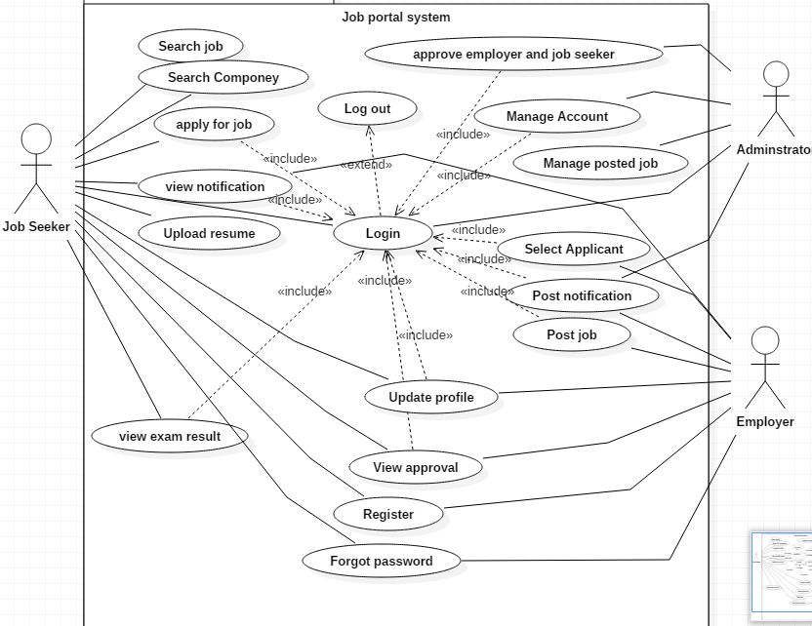

Figure 1 Use case diagrams

## 3.4 Potential Actors and Use Cases

|  |  |
| --- | --- |
| **Actors** | **Use Cases** |
| Administrator  Job Seeker  Employer | Register  Login  Job  Apply for Job  Manage Resume  Manage Profile  Post Job  Add job  Approve Employer  Select Applicant  View Notification  View job detail  View job by category  View job by location  View result |

Table 7 Actors and Use Cases

## 3.5 Use case documentation

|  |  |  |
| --- | --- | --- |
| Use Case Name | **Register** | |
| Use case ID | **UC1** | |
| Actors | Job Seeker, Employer | |
| Purpose | Enable Job Seeker or***/and*** Employer to register | |
| Overview | The Job Seeker or/and the Employer registers  his/her personal information | |
| Pre-condition | Open application  The system displays Home page | |
| **Main Course of Action** | | |
| Actor Action | | System Action |
| 1. Click Register Button 2. Enters personal information 3. Click Save Button   7. Use Case Ends | | 1. Display registration form 2. Verify all inputs   6. Done |
| **Alternative Course of Action** | | |
| 1, If the user enters invalid input, the system displays error messge and goes back to step#2  or if the user registered before, the the system displays “you are already register”. | | |
| Post-condition | The system registers the Job Seeker or Employer | |

Table 8 System Use Case description for register

|  |  |  |
| --- | --- | --- |
| Use Case Name | **Login** | |
| Use case ID | **UC2** | |
| Actors | Job Seeker, Employer, Administrator | |
| Purpose | To Authenticate | |
| Overview | The actors enter the required information and the system will authenticate | |
| Pre –condition | Actors must have user name and password registered in the database | |
| **Main Course of Action** | | |
| Actor Action | | System Action |
| 1. Actors launches the system.  2. Actors click the login button.  4. Actors fill user name and password. | | 3. System display login form.  5. System validate user name and password is correct.  6. Use case ends. |
| **Alternative Course of Action** | | |
| 1. If the actors insert incorrect username or/and password, the system displays message “you are entered incorrect password or username” and system back to basic course of action 4.   2 Use case ends. | | |
| Post-condition | The system display home page | |

Table 9 System Use Case description for Login

|  |  |  |
| --- | --- | --- |
| Use Case Name | **Search Job** | |
| Use case ID | **UC3** | |
| Actor | Job Seeker | |
| Purpose | To search a Job from database | |
| Overview | The Actor enter the name of the Job and the system will display the Job | |
| Pre-condition | Open application | |
| Main Course of Action | | |
| Actor Action | | System Action |
| 1. Click Search Job Button 2. Enter Search Criteria 3. Click Search Button 4. Use Case End | | 2.Display Search Job form   1. Retrieve the Job from the Database 2. Display the Job |
| 1 Alternative Course of Action | | |
| 1, if the actor try to search with an empty field the system The system displays “Please Fill the Criteria ” message and system back to basic course of action 4.  2 use case ends | | |
| 2 Alternative Course of Action | | |
| 1 if the system try to retrieve ajob from the database and no job found The system displays “No Job Found ” message and system back to basic course of action 4.  2 use case ends | | |
| Post-condition | Results of Searched Job display to the Job Seeker | |

Table 10 System Use Case description for Search Job

|  |  |  |
| --- | --- | --- |
| Use Case Name | **View Job Detail** | |
| Use case ID | **UC4** | |
| Actor | Job Seeker | |
| Purpose | To view detail information about the Job | |
| Overview | The actor enters the name of the job and the system will display detail information of the job | |
| Pre-condition | Should receive notification for available jobs  Should have searched a particular job | |
| Main Course of Action | | |
| Actor Action | | System Action |
| 1. Click View Job Detail Button   4. Use Case End | | 1. Retrieve Job Detail from the database 2. Display Job Detail |
| Alternative Course of Action | | |
| 1 Click on Back Button | | |
| Post-condition | The Job Seeker will view Job detail | |

Table 11 System Use Case Description for View Detail

|  |  |  |
| --- | --- | --- |
| Use Case Name | UPLOAD CV | |
| Use Case ID | UC 5 | |
| Actors | Jobseeker | |
| Description | Enables the Actor to add educational detail and upload cv file | |
| Pre-condition | Actors must login to the system. | |
| Post condition | Actor upload cv and required educational details | |
| main course of action | | |
|  | Actors action System action | |
|  | 1. Actors launch the system.  2. Actors Login to a system.  3. Actors click on upload cv button.  5. The actor select file from its disk  6. The actor fills the fields and click upload button. | 4. The system displays a form with required field type selection menu.  7. The system will upload and store on the database  8. Use case ends. |
| Alternative course of action | 1. If the actor tries to upload empty field, the system will displays message “please select file to upload” and system back to basic course of action 3. 2. Use case ends. | |

|  |  |  |
| --- | --- | --- |
| Use Case Name | **Apply for Job** | |
| Use case ID | **UC6** | |
| Actor | Job Seeker | |
| Purpose | Enable Job Seeker to Apply for the Job | |
| Overview | The Job Seeker search for available Jobs to apply that matches with his/her qualification | |
| Pre-condition | Open application  There should exist available job offers | |
| Main Course of Action | | |
| Actor Action | System Action | |
| 1. Click on Notification   3. Click on the Job title  5.Click on apply Button  7.Use Case End | 2.Retrieve and display list of jobs that are available  4.Displays detail Information about the Job  6. Done | |
| Alternative Course of Action | | |
| 1. if the actor changed his mind to cancel the application user can click cancel button | | |
| Post-condition | | Successfully applied |

Table 13 System Use Case description applying for a job

|  |  |  |
| --- | --- | --- |
| Use Case Name | | **Manage resume** |
| Use case ID | | **UC7** |
| Actor | | Job Seeker |
| Purpose | | Enable Jobseeker to post his/her Resume |
| Overview | | The Jobseeker can update and Post his/her resume |
| Pre-condition | | Login to the system  View his/her resume |
| Main Course of Action | | |
| Actor Action | | System Action |
| 1. Click on Resume Button   3.Select his/her Resume  4.Click on Save Button  7.Use Case End | | 1. Display Resume page   5.Check the input  6. Done |
| Alternative Course of Action | | |
| 6a. The system displays “Please Select your Resume” message | | |
| Post-condition | Resume of Jobseeker is posted | |

Table 14 System Use Case Description for Manage resumes

|  |  |  |  |
| --- | --- | --- | --- |
| Use Case Name | **Manage account** | | |
| Use case ID | **UC8** | | |
| Actor | Administrator | | |
| Purpose | The Administrator can view and delete profile | | |
| Overview | The Administrator can manage account | | |
| Pre-condition | Login to the system  View profile | | |
| Main Course of Action | | | |
| Actor Action | | | System Action |
| 1. Click on update account Button   3.the actor click on delete account button  5 the user click on the yes button to delete | | | 2.Retrive and display the account  4.the system display dialogue “are you sure to delete this account ?”  6.display profile successfully updated  7 use case ends |
| Alternative Course of Action | | | |
| 1,if the user click on no button on the dialogue then the action will be aborted and the system back to basic course of action 1  2, use case ends | | | |
| Post-condition | | Manage account | |

Table 15 System Use Case description for managing an Account

|  |  |  |  |
| --- | --- | --- | --- |
| Use Case Name | **Approve Employer** | | |
| Use case ID | **UC9** | | |
| Actor | Administrator | | |
| Purpose | To approve the employer | | |
| Overview | The administrator view registered employers and approve them | | |
| Pre-condition | Employers must be on Pending State | | |
| Main Course of Action | | | |
| Actor Action | | | System Action |
| 1. Click on Approve Button   3.Click on a specific Employer  5.Click on Save Button  7.Use Case End | | | 1. Retrieve and display list of employers which are on pending state   4.Display employer detail  6.Approved |
| Alternative Course of Action | | | |
| 1, if there are no employers in pending state in the database the system displays “No Pending Employer” message and the system back to basic course of action 1  2 use case ends | | | |
| Post-condition | | Employers are approved | |

Table 16 System Use Case description for approve

|  |  |  |  |
| --- | --- | --- | --- |
| Use Case Name | | **Post Job** | |
| Use case ID | | **UC10** | |
| Actor | | Employer | |
| Purpose | | To enable Employer to Post Jobs | |
| Overview | | The employers can post, edit and delete jobs | |
| Pre-condition | | Login into the system  Employers must be approved | |
| Main Course of Action | | | |
| Actor Action | | | System Action |
| 1. Click on Post Job button   3.The Employer fills Job details  4.Click on post Button  7.Use Case Ends | | | 1. Displays Post Job page   5.Checks all inputs  6.Done |
| Alternative Course of Action | | | |
| 1.if all required fieldsare not filled by the employer the system displays “Please fill all required fields” message and the sytem back to basic course of action 3  2 use case ends | | | |
| Post-condition | Job is successfully Posted | | |

Table 17 System Use Case description for posting a job

|  |  |  |
| --- | --- | --- |
| Use Case Name | **Select Applicants** | |
| Use case ID | **UC11** | |
| Actor | Employer | |
| Purpose | Enable the Employer to select applicants from the system | |
| Overview | The Employers can select applicants that fulfills their own company criteria | |
| Pre-condition | The system should shortlist applicants | |
| Main Course of Action | | |
| Actor Action | | System Action |
| 1. Click on View Notified applicants Button   4.Employers view each job seekers detail  5.Click on approve Button  6. Use case end | | 1. Retrieves list of notified applicants from database 2. Display list of eligible applicants |
| Alternative Course of Action | | |
| 1.if the number of applicants are lower than expected or there is no notified applicant The system displays “Minimum number of applicants” message and the system back to basic course of action 1  2 use case ends | | |
| Post-condition | Applicants are selected by Employers | |

Table 18 System Use Case description for select applicants

|  |  |  |  |
| --- | --- | --- | --- |
| Use Case Name | **View Notification** | | |
| Use case ID | **UC12** | | |
| Actor | Job seeker | | |
| Purpose | To enable the job seekers to apply for a job | | |
| Overview | The System evaluates applicant data based on employers’ criteria  The System compares applied applicants based on their resume  The System generates list of eligible applicants and send it to the employers for approval.  The employers check validity of eligible applicants resumes to verify  The System generates an announcement notification for those applicants that they got the job. | | |
| Pre-condition | The system must be generating notification | | |
| Main Course of Action | | | |
| Actor Action | | | System Action |
| 1.click on view notification button  4.use case end | | | 2.retrieves generated notification from database  3.display notification |
| Alternative Course of Action | | | |
| 1 if the system couldn’t find any new notification from the databasethe system generates and displays “no new notification found” message and back to basic course of action 1  2 ,use case ends | | | |
| Post-condition | | The Job seeker apply or reject for a job | |

Table 19 System Use Case description for view notification

|  |  |  |
| --- | --- | --- |
| Use Case Name | **View exam result** | |
| Use case ID | **UC13** | |
| Actor | Jobseeker | |
| Purpose | Enable jobseeker to view exam result | |
| Pre-condition | The user of the system has already activated authenticate user functionality | |
| Overview | Jobseeker can view his/her exam result online | |
| Main Course of Action | | |
| Actor Action | | System Action |
| 1. Click on view exam result button  6. Use case end | | 2.system displays the exam result page  3. Checks whether the user has taken the exam before or not taken and display the exam result |
| Post-condition | | The result of the exam is stored in the database |

Table 20: System Use Case description for the view exam result

## 3.6 Sequence Diagram

A sequence diagram is an interaction diagram that shows how processes operate with one another and in what order.

The boxes across the top of the diagram represent classifiers or their instances; typically use cases, objects, classes or actors.

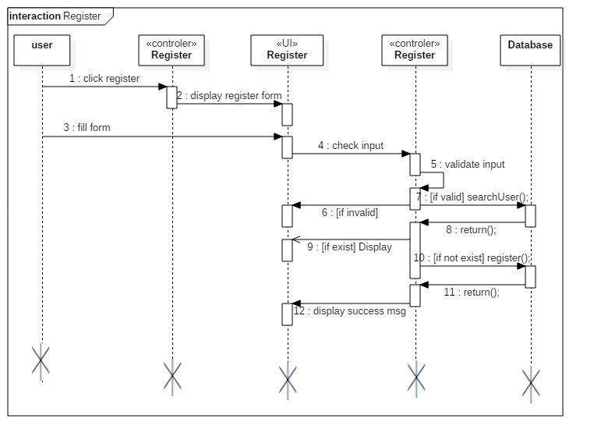

Figure 2 Sequence Diagram for Register

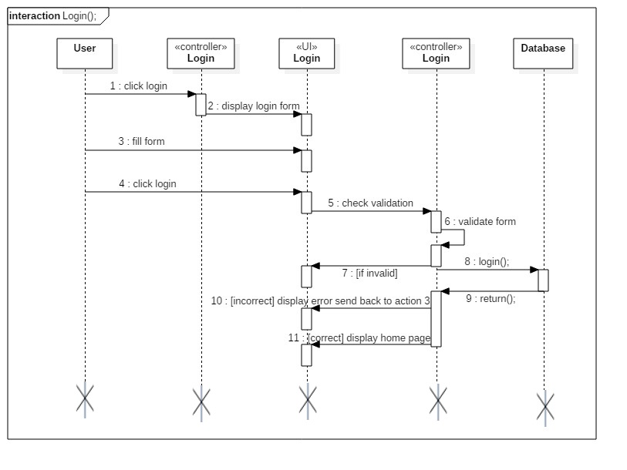

Figure 3 Sequence diagram for login

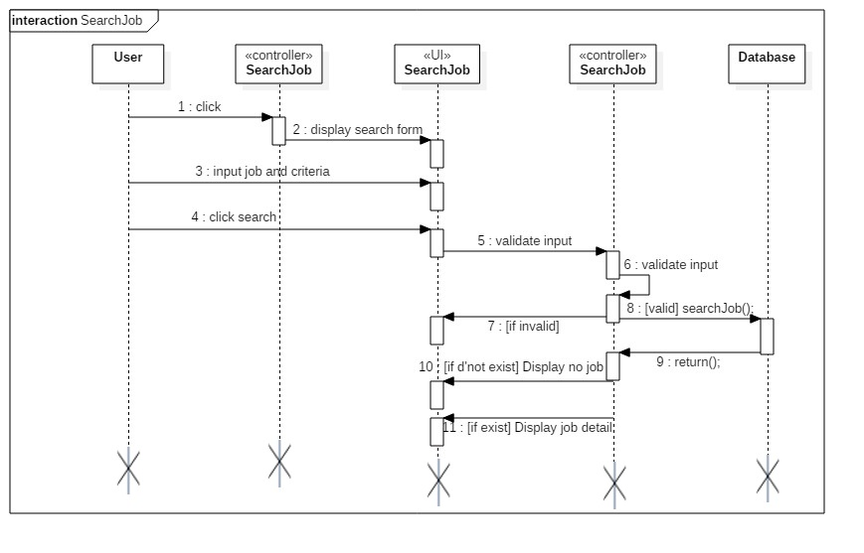

Figure 4 Sequence Diagram for Search Job

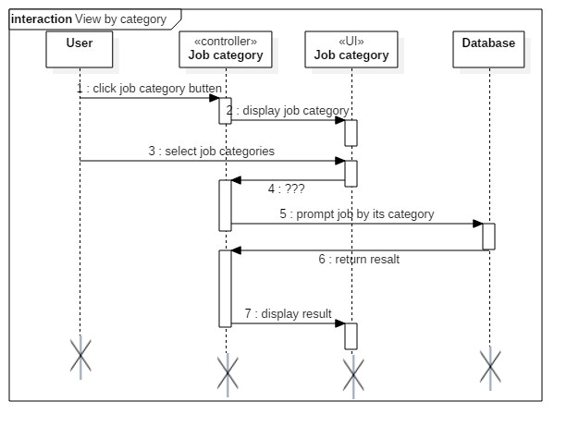

Figure 5 Sequence Diagram for View Job by category

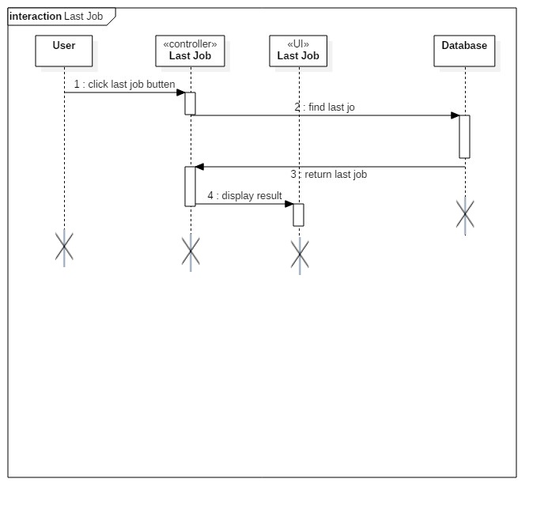

Figure 6 Sequence Diagram for View Latest Job

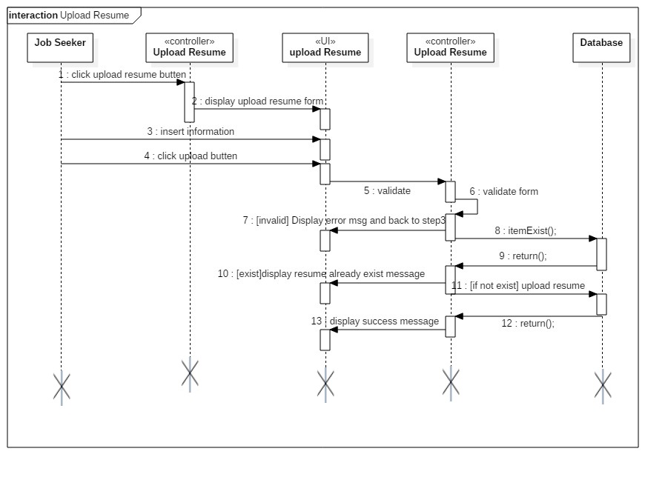

Figure 7 Sequence Diagram for upload Resume

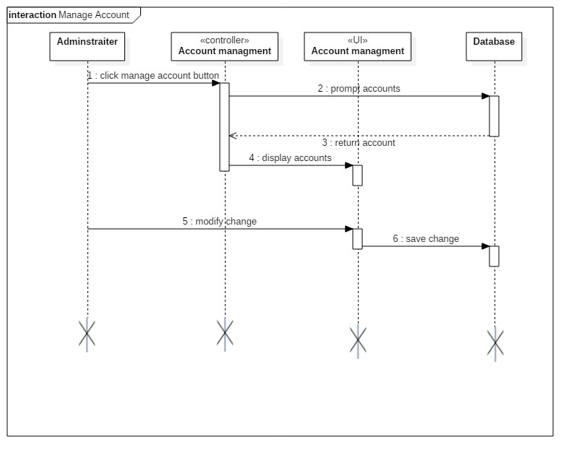

Figure 8 Sequence Diagram for manage account

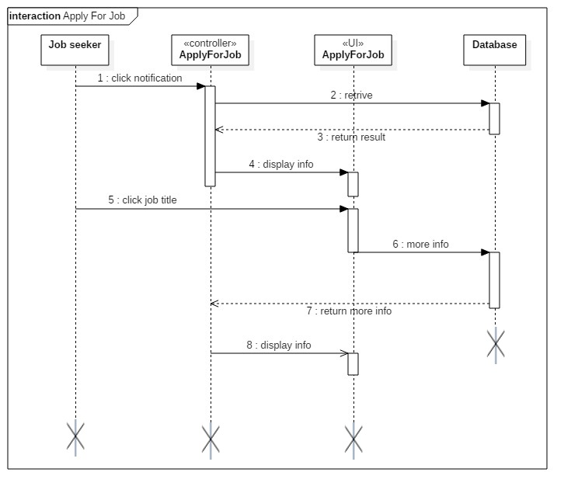

Figure 9 Sequence Diagram for apply job

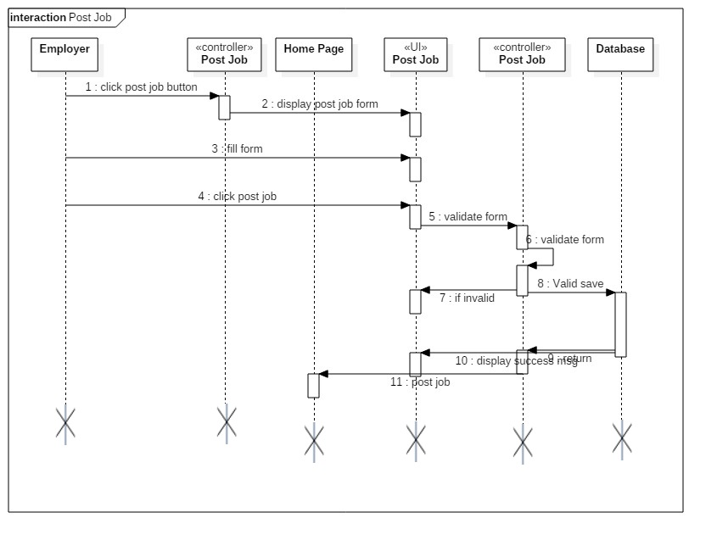

Figure 10 Sequence Diagram for post Job

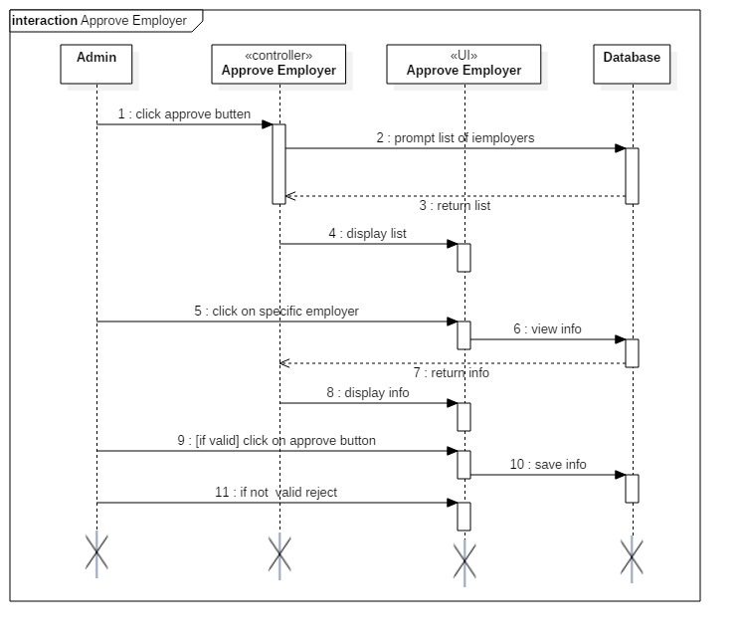

Figure 11: Sequence Diagram for Approve Employer

**3.7 Activity diagram**

The activity diagram specifies the sequence of activities to go through during its lifetime in response to events, together with responses to those events. They have initial and final states. An initial state shows the beginning of work flow on an activity diagram. Final state shows the end of work flow on an activity diagram

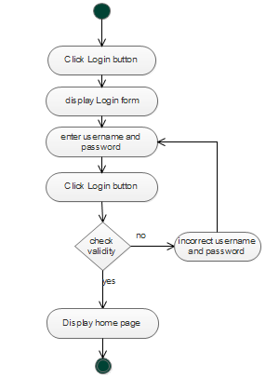

Figure 12Activity Diagram for login

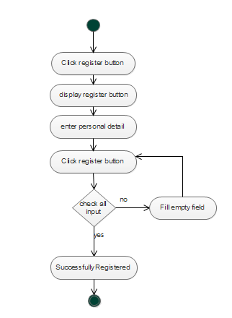

Figure 13 Activity Diagram for register

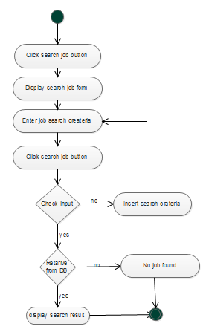

Figure 14 Activity Diagram for Search Job

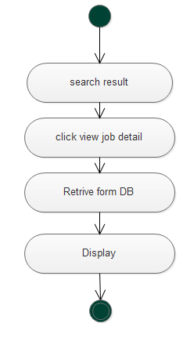

Figure 15 Activity Diagram for View Job Detail

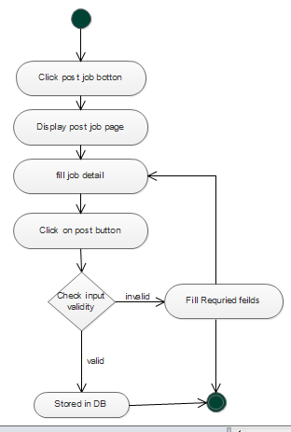

Figure 16 Activity Diagram for Post Job

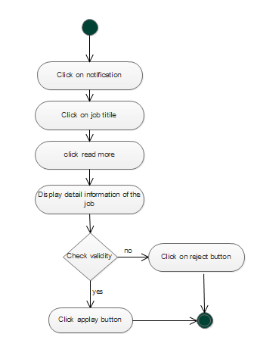

Figure 17 Activity Diagram for View eligible Applicant

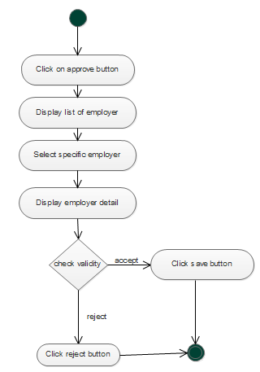

Figure 18 Activity Diagram for Approve Employer

## 3.8 Analysis level class diagram (conceptual modeling)

The class diagram describes the relationship between objects and class. It shows the attributes and operations of each class. 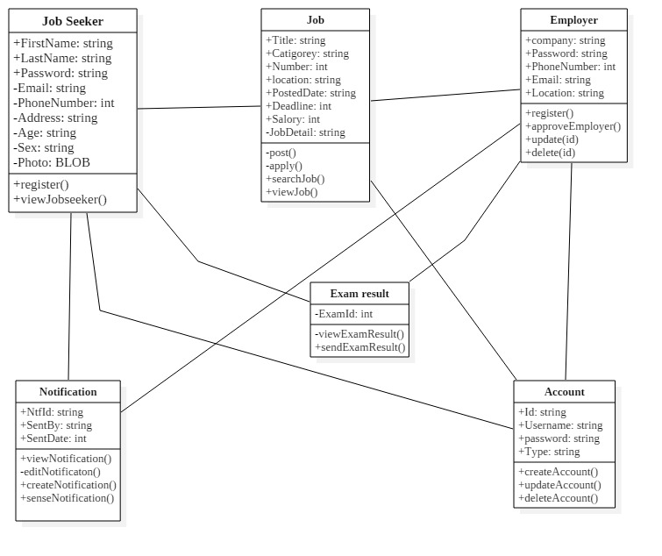

Figure 19 System class diagram

## 3.9 User Interface Prototyping

The application we are going to develop has user-friendly interfaces for Job seekers, Employers, and Administrators for ease interaction and understanding to use the system. 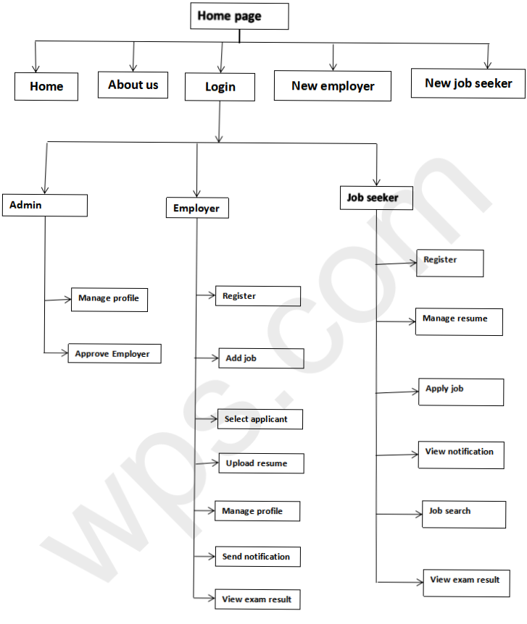

Figure 20: User interface prototype

## 3.10 Supplementary specifications

The Supplementary Specifications capture the system requirements that are not readily captured in the use cases of the use-case model. Such requirements include: -

* Legal and regulatory requirements and application standards.
* Quality attributes of the system to be built, including usability, reliability, performance, and supportability requirements.
* Other requirements such as operating systems and environments, compatibility requirements, and design constraints.
* The other Supplementary specifications are the business rules. The business rules are a principle or a policy in which the proposed system operates accordingly. It deals with the access control issue.

# Chapter Four

# System Design

## 4.1 Introduction

This chapter contains the design goal, system decomposition, system architecture, deployment diagram, persistence data management, access control and security and user interface of the system.

### 4.1.1 Purpose of the System Design Document (SDD)

The purpose of the system design document is to provide a solution for problems that are listed in the analysis phase. Design goals are specification which the system needs to achieve. The following are the purposes of our project design.

**Good response time:** this online job portal will be implemented by PHP programming language, which is in general easier to readable for all browsers. The interfaces are designed such that information can be propagated efficiently. It’s avoided a user waiting time for wherever possible. It minimizes a lot of time for a job seeker by seeing the available jobs and for the employer by recruiting the best candidate.

**Low cost:** This proposed system will minimize cost, which is the cost, spent on papers and other materials.

**Accessibility:** The users can View their resume at any time.

## 4.2 Architectural Design

Architectural design is the process of defining a structured solution that meets all of the technical and operational requirements while optimizing common quality attributes such as performance, security, and manageability. The architecture of a system is one of the major issues that should be given more importance. The architecture plays a main role in modularizing the different components of a system.

The architecture used for the system is a 3 tier Client/Server Architecture.

* **The presentation layer** is the topmost level of the application. It is the one the clients directly interacted with. It provides GUI to allow the client gaining access to the system.
* **Application layer/ Logical tier/ middle tier**: It accepts inputs from the client and performs detailed processing in the database. It also acts as a bridge between the data access tier and the presentation tier.
* **Data layer/ Data access tier**: provides data persistence mechanism and storage to the data. It consists of a mechanism to access the database without installing database dependent drivers and libraries on the client device.

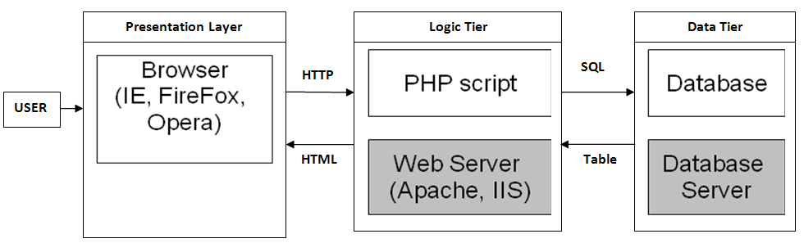

Figure 21: Architecture design of the system

## 4.3 Deployment Diagram

Deployment diagram is used to visualize hardware components of the system, where the system components are deployed.it is used to describe the static deployment view of the system. It consists of nodes and their relationship.

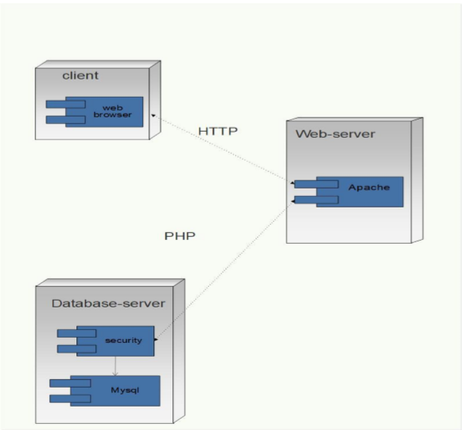

Figure 22: Deployment diagram design

## 4.4 Database Design

Database design is the process of producing a detailed data model of a database. This model contains all the entity-relationship and table, column and key design tools required to create a design that defines detailed attributes for every entity.

A database is simply an organized collection of related data, mostly stored on disks, The database Management System (DBMS) creates and maintain the database, Example of DBMS software available today are; Microsoft access. Oracle Database, MYSQL, Microsoft SQL Server, PostgreSQL, IBM Db2, FileMaker and so on.

For the development of this system, The DBMS used is MYSQL. MYSQL is developed distributed and supported by Oracle Corporation, It is a database system used on the web. MYSQL was chosen because it is very fast, reliable and easy to use and it is ideal for both small and large applications.

**What Do People Expect From an Online Job Portal?**

Both employers and job seekers expect the following functionalities from an online job site:

* People can register as job seekers, build their profiles, and look for jobs matching their skill sets.
* Users can upload their existing resumes. If they do not have one, they should be able to fill out a form and have a resume built for them.
* People can apply directly to posted jobs.
* Companies can register, post jobs, and search job seeker profiles.
* Multiple representatives from a company should be able to register and post jobs.
* Company representatives can view a list of job applicants and can contact them, initiate an interview, or perform some other activity related to their post.
* Registered users should be able to search for jobs and filter the results based on location, required skills, salary, experience level, etc.

### 4.4.1 ER-Diagram

Entity-Relationship (ER) model is a popular high level conceptual data model. This model and its variations are frequently used for the conceptual design of database applications. Object modeling methodologies such as UML (Universal Modeling Language) are becoming increasingly popular in software design and engineering. These methodologies go beyond database design to specify detailed design of software modules and their interactions using various types of diagrams. An important part of these methodologies namely, class diagrams are similar in many ways to the ER diagrams. In class diagrams, operations on objects are specified, in addition to specifying the database schema structure. Operations can be used to specify the functional requirements during database design.

Entity Relationship diagram for our system as follows :-

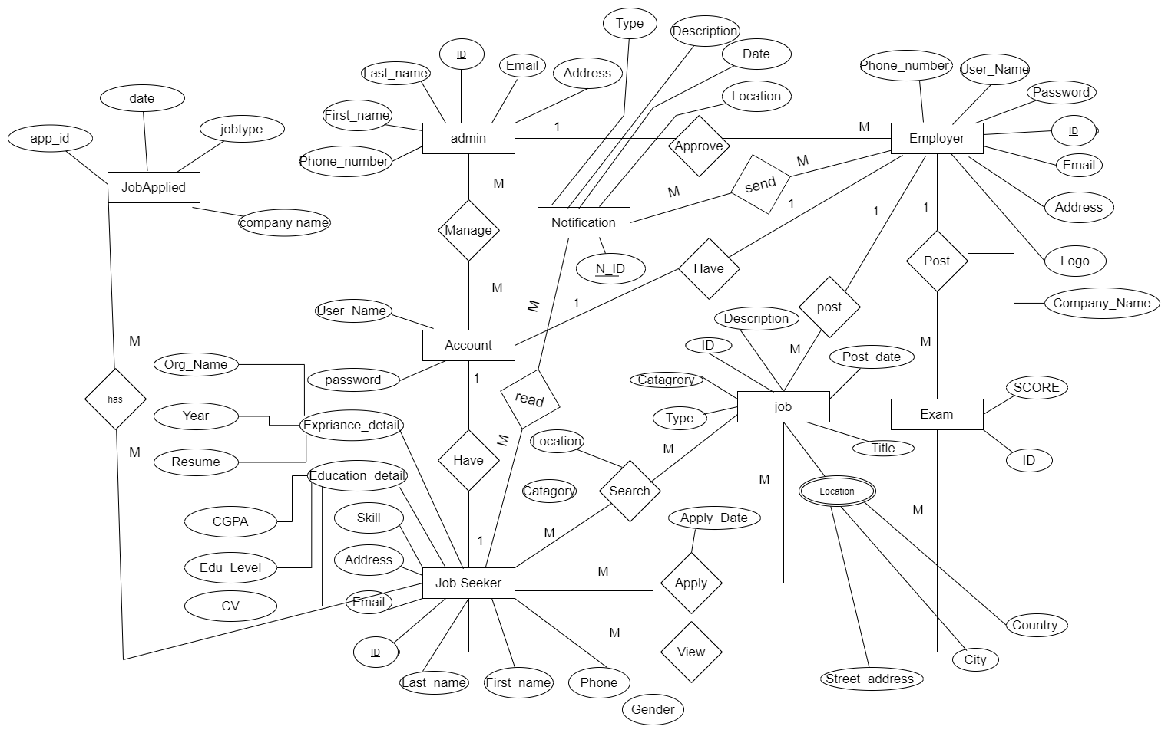

### 4.4.2 Relational Schema

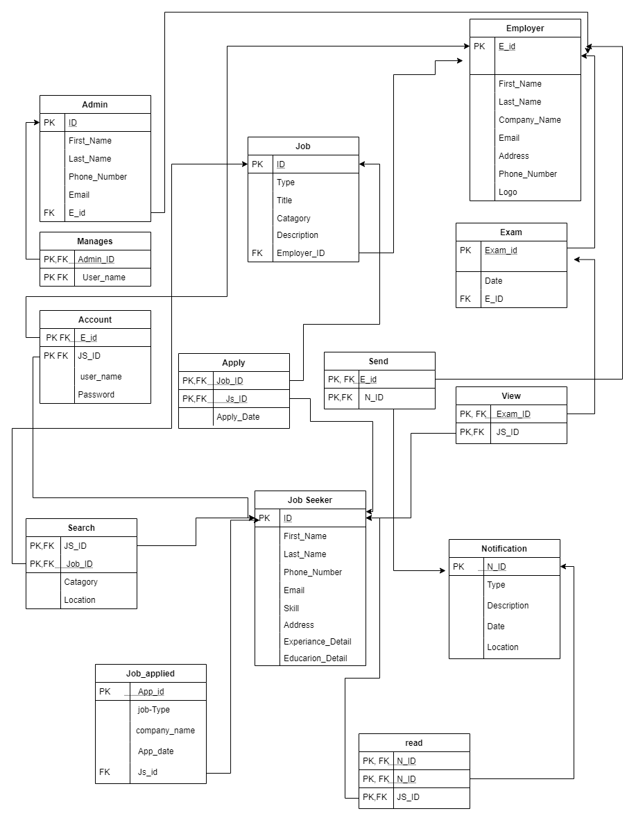

### Database Normalization

The database normalization is the process of the reducing the redundancy of data or tuples in database. This is performed by decomposing a relation into more relation using different set of rules provided by normal form.

Before going to the normalization we should have to identify the functional dependency among the data stored on the table.

1. **Table: Admin**

|  |  |  |  |  |
| --- | --- | --- | --- | --- |
| ID | First_Name | Last_Name | Phone_Number | Address |
| PK |  |  |  |  |

From this table:

* ID can determine -> First_Name, Last_Name, Phone_Number and Address.
* Phone_Number is a multivalued attribute.
* Address is a composite attribute.

1. **Table: Employer**

|  |  |  |  |  |  |  |  |
| --- | --- | --- | --- | --- | --- | --- | --- |
| ID | User_name | Password | Company_Name | Email | Address | Phone | Logo |
| PK |  |  |  |  |  |  |  |

From this table:

* ID can determine -> User_name, Password, Copany_name, Email Address, Phone, and Logo.
* Phone_Number is a multivalued attribute.
* Address is a composite attribute.

1. **Table: Job seeker**

|  |  |  |  |  |  |  |  |  |
| --- | --- | --- | --- | --- | --- | --- | --- | --- |
| ID | First_Name | Last_Name | Phone_Number | Email | Skill | Address | Experience_Detail | Education_detail |
| PK |  |  |  |  |  |  |  |  |

From this table:

* ID can determine -> First_name, Last_name, Phone_number, Email, Skill. Address, Experience_detail, Education_detail.
* Phone_Number is a multivalued attribute.
* Address is a composite attribute.

1. **Table: Job**

|  |  |  |  |  |
| --- | --- | --- | --- | --- |
| ID | Type | category | Description | Employer_ID |
| PK |  |  |  | FK |

From this table:

* ID can determine -> Type, Category, Description, Employer_ID.
* Employer_ID is a foreign key comes from Employer table

1. **Table: Manage**

|  |  |
| --- | --- |
| Admin_ID | Name |
| FK |  |

From this table:

* Manage is a relation between entity called Admin and Account.
* Admin_ID can determine -> the name of the account that the admin Manages
* Admin_ID is a foreign key comes from Admin table

1. **Table: Search**

|  |  |  |  |
| --- | --- | --- | --- |
| Job_ID | Jobseeker_ID | Category | Location |
| FK | FK |  |  |

From this table:

* Search is a relation between entity called Job and Job seeker.
* Job_ID and Jobseeker_ID determine -> Category and Location
* Both Job_ID and Jobseeker_ID are foreign keys comes from the job and Jobseeker table respectively.

1. **Table: Apply**

|  |  |  |
| --- | --- | --- |
| Job_ID | Jobseeker_ID | Apply_date |
| FK | FK |  |

From this table:

* Apply is a relation between entity called Job and Job seeker.
* Job_ID and Jobseeker_ID determine -> Apply_date
* Both Job_ID and Jobseeker_ID are foreign keys comes from the job and Jobseeker table respectively.

1. **Table: Exam**

|  |  |  |
| --- | --- | --- |
| ID | Date | Employer_ID |
| PK |  | FK |

From this table:

* ID determine -> Date and Employer_ID
* Employer_ID is a foreign key comes from the Employer table.

1. **Table: View**

|  |  |
| --- | --- |
| Exam_ID | Jobseeker_ID |
| FK | FK |

From this table:

* View is a relation between entity called Exam and Job seeker.
* Both Exam_ID and Jobseeker_ID are foreign keys comes from the Exam and Jobseeker table respectively.

1. **Table: Notification**

|  |  |  |  |  |
| --- | --- | --- | --- | --- |
| N_ID | Type | Description | Date | Location |
| PK |  |  |  |  |

From this table:

* N_ID determines type, description, Date, Location
* No multivalued attrubte.
* No composite attribute.
* No partial dependency

#### **First Normal Form (1NF)**

As we have seen from the above tables we have Nine database tables we declare to store the data on the database. It is not normalized to reduce the redundancy and inconsistency of the data on the database. To reduce such anomalies from the database we have to normalize it through different steps.

In this normal form all the redundant tuple will be listed on the table having the redundant tuples will be expanded to store the data in single cell. Therefore if relation schema does not contain any multiple attribute.

From the above listed tables, some are in the **first normal form** (1NF). **Table 4,5,6,7,8 and 9** are in a 1NF.

1. **Table: Job**

|  |  |  |  |  |
| --- | --- | --- | --- | --- |
| ID | Type | category | Description | Employer_ID |
| PK |  |  |  | FK |

1. **Table: Manage**

|  |  |
| --- | --- |
| Admin_ID | Name |
| FK |  |

1. **Table: Search**

|  |  |  |  |
| --- | --- | --- | --- |
| Job_ID | Jobseeker_ID | Category | Location |
| FK | FK |  |  |

1. **Table: Apply**

|  |  |  |
| --- | --- | --- |
| Job_ID | Jobseeker_ID | Apply_date |
| FK | FK |  |

1. **Table: Exam**

|  |  |  |
| --- | --- | --- |
| ID | Date | Employer_ID |
| PK |  | FK |

1. **Table: View**

|  |  |
| --- | --- |
| Exam_ID | Jobseeker_ID |
| FK | FK |

1. **Table: Notification**

|  |  |  |  |  |
| --- | --- | --- | --- | --- |
| N_ID | Type | Description | Date | Location |
| PK |  |  |  |  |

The rest of tables from the above listed are not in the first form of database. Therefore it need normalization as each of them are explained below.

1. **1NF of the Admin data schema**

**Table: Admin**

|  |  |  |  |  |
| --- | --- | --- | --- | --- |
| ID | First_Name | Last_Name | Phone_Number | Email |

* In this table Phone number and email are multivalued attribute.

**Table: Admin**

|  |  |  |  |  |
| --- | --- | --- | --- | --- |
| ID | FN | LN | Phone | Email |
| 01 | Bruk | Admasu | 0923232323  0922090909 | b@gmail.com  B1@gmail.com |

When we expand it, it look the following

**1NF Table: Admin**

|  |  |  |  |  |  |  |
| --- | --- | --- | --- | --- | --- | --- |
| ID | First_Name | Last_Name | P_ID | Phone | E_ID | Email |
| 01 | Bruk | Admasu | p101 | 0923232323 | E101 | b@gmail.com |
| 01 | Bruk | Admasu | p202 | 0922090909 | E202 | B1@gmail.com |

* From the above table we see that there is no repeated value in a cell for the same attribute.
* Therefore, it is in the 1NF.

1. **1NF of the Employer data schema**

**Table: Employer**

|  |  |  |  |  |  |  |  |
| --- | --- | --- | --- | --- | --- | --- | --- |
| ID | User_name | Password | Company_Name | Email | Address | Phone | Logo |
| PK |  |  |  |  |  |  |  |

* In this table email and Phone number are multivalued attribute.
* Address is a composite attribute

**Table: Employer**

|  |  |  |  |  |  |  |  |
| --- | --- | --- | --- | --- | --- | --- | --- |
| ID | User_name | Password | Company_Name | Email | Address | Phone | Logo |
| 01 | HwOMO | 123123 | OMO | omo@gmail.com  omm@gmail.com | Hawassa | 0923232323  0922090909 |  |

When we expand it, it look the following?

**1NF Table: Employer**

|  |  |  |  |  |  |  |  |  |  |  |  |
| --- | --- | --- | --- | --- | --- | --- | --- | --- | --- | --- | --- |
| ID | User_name | Password | Company_Name | E_id | Email | Address | P_ID | Phone | Logo | Location | State |
| 01 | HwOMO | 123123 | OMO | 001 | omo@gmail.com | Hawassa | 101 | 0923232323 |  | Hawassa | Debub |
| 01 | HwOMO | 123123 | OMO | 002 | omm@gmail.com | Hawassa | 102 | 0922090909 |  | Hawassa | Debub |

* From the above table we see that there is no repeated value in a cell for the same attribute.
* Therefore, it is in the 1NF.

1. **1NF of the Jobseeker data schema**

**Table: Jobseeker**

|  |  |  |  |  |  |  |  |  |
| --- | --- | --- | --- | --- | --- | --- | --- | --- |
| ID | First_Name | Last_Name | Phone_Number | Email | Skill | Address | Experience_Detail | Education_detail |
| PK |  |  |  |  |  |  |  |  |

* In this table email, skill and Phone number are multivalued attribute.
* Address and Education detail are a composite attribute

|  |  |  |  |  |  |  |  |  |
| --- | --- | --- | --- | --- | --- | --- | --- | --- |
| ID | First_Name | Last_Name | Phone_Number | Email | Skill | Address | Experience_Detail | Education_detail |
| 01 | Abebe | Kebede | 0911122334  0932341223 | Abe@gmail.com  Kebe@gmail.com | Typing  Multiple language | 0923232323  0922090909 |  |  |

**1NF Table: Jobseeker**

|  |  |  |  |  |  |  |  |  |  |
| --- | --- | --- | --- | --- | --- | --- | --- | --- | --- |
| ID | First_Name | Last_Name | P_ID | Phone_Number | E_ID | Email | Skill_ID | Skill | Address |
| 01  01 | Abebe  Abebe | Kebede  Kebede | 101  102 | 0911122334  0932341223 | 111  222 | Abe@gmail.com  Kebe@gmail.com | 01  02 | Typing  Multiple language | 0923232323  0922090909 |

|  |  |  |  |  |  |
| --- | --- | --- | --- | --- | --- |
| Org_Name | Year | Resume | CGPA | Education_Lvl | CV |
| HawassaUniv  HawassaUniv | 2009  2009 | ….  ….. | 3.9  3.9 | Masters  Masters | ….  …. |

1. From the above table we see that there is no repeated value in a cell for the same attribute.
2. Therefore, it is in the 1NF.

**Second Normal Form (2NF)**

In any relational data normalized to a second normal form, there is no multivalued attributes and if there is partial dependence among the data in the database, it normalized by the second normal form. That mean to normalize the database into the 2NF, we must identify the functional dependence between the key attributes and non-key attributes. In our relational case let us see in the following tables. Some of the tables are in the second normal form because of they have no partial dependence between the primary key and non-primary key attributes. For example tables **4, 5, 6, 7,8 and 9** are in a 2NF.

1. **Table: Job**

|  |  |  |  |  |
| --- | --- | --- | --- | --- |
| ID | Type | category | Description | Employer_ID |
| PK |  |  |  | FK |

1. **Table: Manage**

|  |  |
| --- | --- |
| Admin_ID | Name |
| FK |  |

1. **Table: Search**

|  |  |  |  |
| --- | --- | --- | --- |
| Job_ID | Jobseeker_ID | Category | Location |
| FK | FK |  |  |

1. **Table: Apply**

|  |  |  |
| --- | --- | --- |
| Job_ID | Jobseeker_ID | Apply_date |
| FK | FK |  |

1. **Table: Exam**

|  |  |  |
| --- | --- | --- |
| ID | Date | Employer_ID |
| PK |  | FK |

1. **Table: View**

|  |  |
| --- | --- |
| Exam_ID | Jobseeker_ID |
| FK | FK |

1. **Table: Notification**

|  |  |  |  |  |
| --- | --- | --- | --- | --- |
| N_ID | Type | Description | Date | Location |
| PK |  |  |  |  |

* The following table are not in the second normal form. It needs to drop out the partial dependency in separate table.

1. **2NF of the Admin Data schema**

**Table: Admin**

|  |  |  |  |  |  |  |
| --- | --- | --- | --- | --- | --- | --- |
| ID | First_Name | Last_Name | P_ID | Phone | E_ID | Email |
| 01 | Bruk | Admasu | p101 | 0923232323 | E101 | b@gmail.com |
| 01 | Bruk | Admasu | p202 | 0922090909 | E202 | B1@gmail.com |

* It is in the first normal form.
* From the above table we have for primary key. These are: ID, E_ID, and P_ID.
* It has partially dependent attributes in the data table.
* Therefore, it will be normalized to the following data table.

**Table: Admin**

|  |  |  |  |  |
| --- | --- | --- | --- | --- |
| ID | First_Name | Last_Name | E_ID | P_ID |

|  |  |
| --- | --- |
| EID | Email |
|  |  |

**Table:PhoneNo** **Table:Email**

|  |  |
| --- | --- |
| P_ID | Phone_Number |
|  |  |

* It is in the first normal form.
* There is no partial dependence in this table of data.
* All the attributes are determined by one key attribute

1. **2NF of the Employer Data schema**

**Table: Employer**

|  |  |  |  |  |  |  |  |  |  |  |  |
| --- | --- | --- | --- | --- | --- | --- | --- | --- | --- | --- | --- |
| ID | User_name | Password | Company_Name | E_id | Email | Address | P_ID | Phone | Logo | Location | State |
| 01 | HwOMO | 123123 | OMO | 001 | omo@gmail.com | Hawassa | 101 | 0923232323 |  | Hawassa | Debub |
| 01 | HwOMO | 123123 | OMO | 002 | omm@gmail.com | Hawassa | 102 | 0922090909 |  | Hawassa | Debub |

As we see from the above the tables:

* It is in the first normal form.
* From the above table we have for primary key. These are: ID, E_ID, and P_ID.
* There is a partial dependence in this table of the data.
* It is normalized to the following table of data.

**Table: Employer**

|  |  |  |  |  |  |
| --- | --- | --- | --- | --- | --- |
| ID | First_Name | Last_Name | P_ID | E_ID | Address |

|  |  |
| --- | --- |
| EID | Email |
|  |  |

**Table:PhoneNo** **Table:Email**

|  |  |
| --- | --- |
| P_ID | Phone_Number |
|  |  |

* It is in the first normal form.
* There is no partial dependence in this table of data.
* All the attributes are determined by one key attribute

1. **2NF of the Job seeker Data schema**

|  |  |  |  |  |  |  |  |  |  |
| --- | --- | --- | --- | --- | --- | --- | --- | --- | --- |
| ID | First_Name | Last_Name | P_ID | Phone_Number | E_ID | Email | Skill_ID | Skill | Address |
| 01  01 | Abebe  Abebe | Kebede  Kebede | 101  102 | 0911122334  0932341223 | 111  222 | Abe@gmail.com  Kebe@gmail.com | 01  02 | Typing  Multiple language | 0923232323  0922090909 |

|  |  |  |  |  |  |
| --- | --- | --- | --- | --- | --- |
| Org_Name | Year | Resume | CGPA | Education_Lvl | CV |
| HawassaUniv  HawassaUniv | 2009  2009 | ….  ….. | 3.9  3.9 | Masters  Masters | ….  …. |

As we see from the above the tables:

* It is in the first normal form.
* From the above table we have for primary key. These are: ID, E_ID, and P_ID.
* There is a partial dependence in this table of the data.
* It is normalized to the following table of data.

**Table: Job seeker**

|  |  |  |  |  |  |  |  |  |
| --- | --- | --- | --- | --- | --- | --- | --- | --- |
| JS_ID | First_Name | Last_Name | P_ID | E_ID | Skill_ID | Address | Experience_ID | Educationdetail_ID |

|  |  |
| --- | --- |
| E_ID | Email |
|  |  |

**Table:PhoneNo** **Table:Email**

|  |  |
| --- | --- |
| P_ID | Phone_Number |
|  |  |

**Table: Experiance**

|  |  |  |  |  |
| --- | --- | --- | --- | --- |
| Experience_ID | Phone_Number | Org_Name | Year | Resume |
|  |  |  |  |  |

|  |  |  |  |
| --- | --- | --- | --- |
| Educationdetail_ID | CGPA | Education_Lvl | CV |
|  |  |  |  |

**Table: Education_Detail**

* It is in the first normal form.
* There is no partial dependence in this table of data.
* All the attributes are determined by one key attribute

# Chapter Five

# Conclusion and Recommendation

It has been a used pleasure for us to work on this exciting and challenging project. This project proved good for our team as it provided a practical knowledge of not only programming in PHP and JavaScript. It also provides knowledge about the latest technology used in developing web-enabled applications and client-server technology that will be great demand in the future. This will provide better opportunities and guidance in the future in developing projects independently.

**BENEFITS:**

The project is identified by the merits of the system offered to the user. The merits of this project are as follows: -

* It’s a web-enabled project.
* This project offers the user to enter the data through simple and interactive forms. This is very helpful for the client to enter the desired information through so much simplicity.
* The user is mainly more concerned about the validity of the data, whatever he is entering. There are checks on every stage of any new creation, data entry or update so that the user cannot enter the invalid data, which can create problems at later date.
* Sometimes the user finds in the later stages of using a project that he needs to update some of the information that he entered earlier. There are options for him by which he can update the records. Moreover, there is a restriction for him that he cannot change the primary data field. This keeps the validity of the data to a longer extent.
* The user is provided the option of monitoring the records he entered earlier. He can see the desired records with a variety of options provided by him.
* From every part of the project, the user is provided with the links through framing so that he can go from one option of the project to another as per the requirement. This is bound to be simple and very friendly as per the user is concerned. That is, we can sit that the project is user-friendly which is one of the primary concerns of any good project.
* Data storage and retrieval will become faster and easier to maintain because data is stored in a systematic manner.
* The decision-making process would be greatly enhanced because of the faster processing of information since data collection from information available on the computer takes much less time than the manual system.
* Allocating of sample results becomes much faster because at a time the user can see the records of last years.
* Through these features, it will increase the efficiency, accuracy, and transparency,

**LIMITATIONS:**

* The size of the database increases day-by-day, increasing the load on the database back up and data maintenance activity.
* Training for simple computer operations is necessary for users working on the system.

# 5.1 Recommendation

According to scope of this project the team develops web based system. Because of the time constraint we may have limitation which should be consider in, but in the feature the team believes that this system should be fully operationally by adding some functionality that are not included in the proposed system, and our suggestion go thus

* It is good if other languages are integrated with this system, if other languages are integrated to this system, the system became universal any user can use the system simply.
* This system would start to also take care where appliers can take an interview online
* Finally, we would add where companies sets up a question and where seeker answers them to be qualified for the company.

**5.3 APPENDEX**

**Symbols used in analysis model**

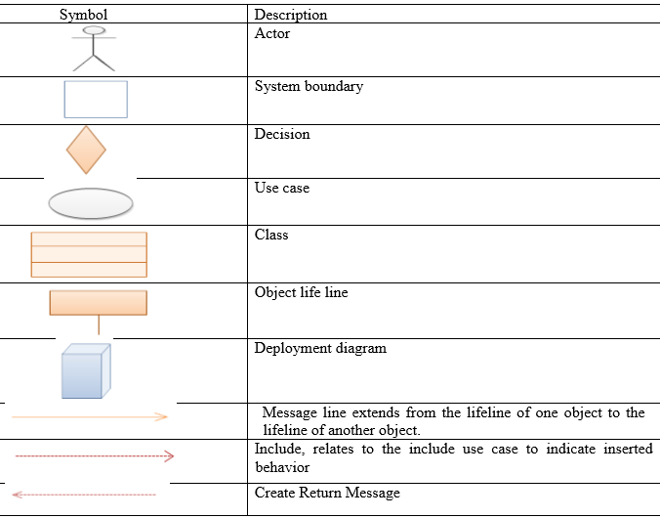

# Bibliography

|  |  |
| --- | --- |
| [1] | "http://www.scribd.com," 2009. [Online]. Available: "]http://www.scribd.com," ]http://www.scribd.com, 2009. [Online]. Available: http://www.scribd.com/doc/8574409/job portal.. |
| [2] | B. N. H. I. P. C. S. G, "Architectural and Compiler Techniques for job portal," *Trans Large Scale Integration,* vol. 2, 2000. |
| [3] | S. F. .. Smith, "IS Scheduling a Solved Problem," *multidisciplinary methodology and algorithms,* vol. 17, 2005. |
| [4] | "Job portal websites," [Online]. Available: www.ethiojobs.com, www.ezega.com, www.exthio.com. |
| [5] | A. F. B. L. S. &. C. A. Broughton, "The use of social media in the recruitment process s.l.: s.n.," 2013. |
| [6] | E. Asamoah, "The Design and Implementation of Online Recruitment System (using Unisky Group of Companies)," 2016. |
| [7] | R. J. Stone, "Raymond J. Stone," vol. 5, 2005. |
| [8] | M. &. M. N. Y. Mansourvar, " Wob portal as a knowledge management system in the universitites," in *World Academy of Sicence, Engineering and Technology*, 2010, pp. 968-974. |